2018-2019
Student Calendar

September 4, 2018 First Day for all Students (Tuesday)

September 20, 2018 Fall Parent/Student Orientation 5:00 – 7:30 p.m.

November 8, 2018 Parent/Teacher Conferences 5:00 – 7:30 p.m.

November 22 & 23, 2018 Thanksgiving Holiday (No School)

Dec. 24 – Jan. 4, 2019 Winter Break (No School)

January 7, 2019 Students Return (Monday)

January 18, 2019 End of 1st Semester

January 21, 2019 Martin Luther King (No School)

January 22, 2019 Start of 2nd Semester

January 24, 2019 Career Night 5:00 – 7:30 p.m. (new students only)

February 18 – 22, 2019 Mid-Winter Break (No School)

April 1 – 5, 2019 Spring Break (No School)

April 25, 2019 Signing Day 5:00 – 8:00 p.m. (new students only)

May 27, 2019 Memorial Day (No School)

June 2019 Last Student Day is determined by Sending District

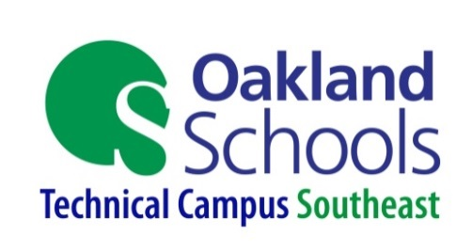
Oakland Schools Technical Campus – Southeast
5055 Delemere Street, Royal Oak, MI 48073
Main Office: 248-288-4020 Fax: 248-288-4071
Campus Website:
www.ostconline.com
Hours of Operation:
Office Hours: 7:00 a.m. – 3:30 p.m.
Students: Morning Session 7:50 a.m. to 10:20 a.m.
Afternoon Session 12:00 noon to 2:30 p.m.

Attendance Line Numbers:

Class | Number
Automotive Technology | 248-288-4368
Collision Repair | 248-288-4372
Construction Technology | 248-288-4889
Criminal Justice | 248-288-4201
Culinary Arts | 248-288-4326
Cyber Security | 248-288-4229
Energy/Electrical | 248-288-4406
Entrepreneurship/Adv. Marketing | 248-288-4253
Health Sciences | 248-288-4616
Machining | 248-288-4219
Mechatronics | 248-288-4357
Programming | 248-288-4253
Visual Imaging | 248-288-4295
Welding | 248-288-4027

