**Tuesday, April 29, 2014 5:00-8:00 PM**

**Class of 2016 Wendy’s Fundraiser**



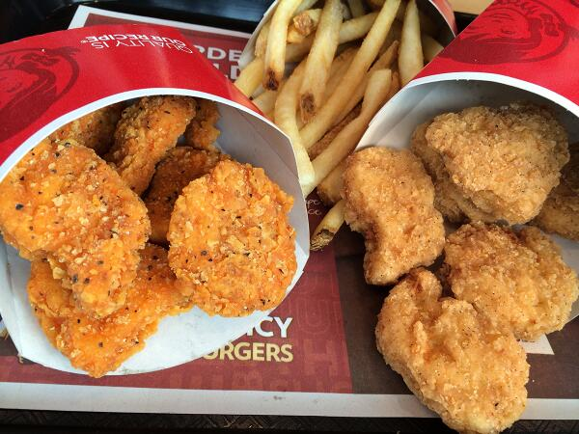



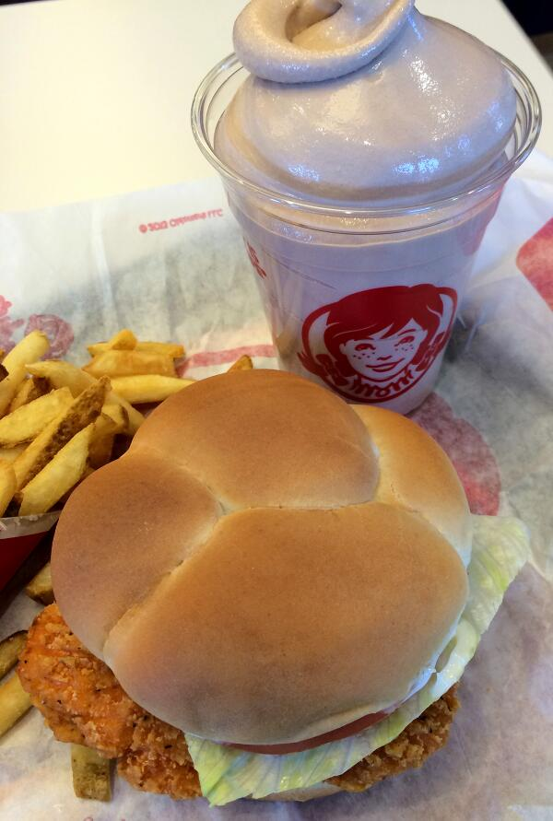

Grab your dinner at Wendy’s & support the Class of 2016!

50% of the proceeds from the dining room will go towards the Southfield-Lathrup High School Class of 2016.

You must come inside. Drive-thru orders do not count!

You’ll be entered into a raffle just for coming in! Enjoy your food in the dining room or take it to go. We hope to see you there!